PRODUCT REQUIREMENT DOCUMENT (PRD)
UMHackathon 2026
umhackathon@um.edu.my
_______________________________________________
Group | newbee
Group member | - WONG JIA HUI  - TAN CAI JUAN  - LEE JUN RUI
Domain | 2

Table of Contents
1. Project Overview 1
2. Background & Business Objective 1
3. Product Purpose 2
4. System Functionalities 2
5. User Stories & Use Cases 3
6. Features Included (Scope Definition) 3
7. Features Not Included (Scope Control) 3
8. Assumptions & Constraints 4
9. Risks & Questions Throughout Development 4

Project Name: GigOptimizer AI
Version: 1.0
1. Project Overview
- Problem Statement: Gig workers in Malaysia often make task acceptance and scheduling decisions using fragmented platform information, intuition, and rapidly changing external conditions such as traffic congestion, weather uncertainty, fuel costs and fluctuating demand. This often leads to inefficient task selection, reduced earnings, higher operating costs and lost opportunities. Existing gig platforms focus on task distribution and automation but provide limited intelligent decision support that helps workers evaluate trade-offs and optimize outcomes.
- Target Domain: AI for Economic Empowerment & Decision Intelligence.
- Proposed Solution Summary: GigOptimizer AI is an AI-powered decision intelligence platform that helps gig workers make smarter, data informed decisions regarding which tasks to accept, how to optimize schedules, and how to maximize income. By integrating Z.AI’s GLM as the core reasoning engine, the system interprets structured task metrics and contextual inputs, generates explainable recommendations, performs trade-off analysis and supports economically beneficial decisions.

2. Background & Business Objective
- Background of the Problem: Gig workers often operate under uncertainty with limited analytical support. They must independently assess whether a task is profitable, whether waiting for a better opportunity is worthwhile, how traffic or weather affects outcomes, and how to balance short-term earnings with long-term productivity. This fragmented manual decision-making can reduce efficiency and earnings.
- Importance of Solving This Issue: Providing AI-assisted decision support can improve income optimization, reduce wasted time, lower fuel related inefficiencies and empower workers to make more strategic economic decisions. This is especially impactful for individuals relying on gig work as a primary income source.

- Strategic Fit / Impact: GigOptimizer AI aligns strongly with the AI for Economic Empowerment & Decision Intelligence theme by:
- Improving productivity through better task decisions
- Reducing operating costs through route and schedule optimization
- Increasing revenue potential through AI-supported task prioritization
- Demonstrating measurable economic empowerment through decision intelligence

3. Product Purpose
3.1. Main Goal of the System: To provide gig workers with an AI-enabled decision support partner that recommends optimal actions, explains trade-offs clearly and helps maximize economic outcomes.
3.2. Intended Users (Target Audience):

Delivery Riders

Ride-Hailing Drivers

Gig Platform Workers

Freelancers handling task-based jobs

New or inexperienced gig workers needing decision support

4. System Functionalities
4.1. Description: The system operates as an AI-powered decision intelligence engine combining structured task metrics, contextual signals and GLM reasoning. It analyzes gig opportunities and provides explainable recommendations through a dashboard interface.
4.2. Key Functionalities:
- Smart Task Recommendation: Analyzes multiple gig opportunities and recommends which tasks to prioritize based on profitability, efficiency and contextual conditions.
- Smart Schedule Optimization: Suggests optimal work periods and task sequencing to reduce idle time and improve productivity.
- Income Optimization Advisor: Provides strategic guidance to increase projected earnings and improve revenue consistency.
- Trade-Off Analyzer: Compares two or more opportunities and recommends economically optimal choice while explaining risks and trade-offs 4.3. AI Model & Prompt Design
4.3.1. Model Selection
Selected Model: Z.AI GLM
Justification: Z.AI GLM was selected due to its strong context-aware reasoning capabilities, ability to interpret structured and unstructured inputs, explainable response generation, action recommendation support and structured output generation suitable for decision support. Besides, GLM is the core intelligence layer of the product. Removing GLM would eliminate the reasoning and decision support capabilities central to the solution.
4.3.2. Prompting Strategy:
The system uses multi-step structured prompting:
1. Compute task-level metrics first
2. Inject worker context + environmental signals
3. Use constrained prompts requesting reasoning + recommendations
4. Parse structured outputs into dashboard recommendations
The system fits because of its improvement in consistency, reduces hallucination risk, supports explainable decisions and matches decision intelligence use case.
4.3.3. Context & Input Handling:
Inputs handled include:
- Structured task metrics
- Worker profile preferences
- Traffic and weather conditions
- Earnings history inputs
Input Handling Strategy:
- Context is bounded through prompt scoping
- Large inputs are summarized or chunked before inference
- Oversized requests trigger truncation logic before reaching GLM
Prototype maximum practical context: approximately 1500–2000 token equivalent per request.
4.3.4. Fallback & Failure Behavior:
If GLM returns unusable or unavailable outputs:
- Retry logic is triggered
- Structured fallback recommendations are used in demo mode
- User receives graceful error messaging instead of system failure
- Output is constrained to reduce hallucination risk

5. User Stories & Use Cases
- User Stories:
  - As a motorcycle delivery rider, I want to know which of today's available tasks will give me the highest net pay after fuel costs, so that I stop losing money on long low-value routes.
  - As a ride-hail driver, I want the system to tell me when and where to position my car for surge pricing, so that I earn 2x without guessing.
  - As a freelance gig worker, I want to understand whether taking a quick delivery job or completing a design task first will earn me more today, so that I make an informed trade-off in under 30 seconds.
  - As any gig worker, I want the system to explain its recommendation in plain Malay-English, so that I trust it and act on it without needing to understand the algorithm.
- Use Cases (Main Interactions):
Use Case 1: GLM Task Ranking Flow
Worker opens the Task Selection panel → selects worker profile → clicks 'Run GLM Analysis' → backend constructs combined context block (structured metrics + unstructured signals) → GLM returns ranked JSON → frontend renders top 3 recommendations with risk flags, net earnings, and avoidance alerts.

Use Case 2: Smart Schedule Generation
Worker sets daily earnings target (e.g., MYR 150) → clicks 'Generate Schedule' → GLM reasons about surge windows, task time constraints, and geographic clustering → returns hour-by-hour schedule → worker sees projected MYR total, effective hourly rate, and time saved versus unoptimised routing.

Use Case 3: Trade-off Decision
Worker selects two competing tasks from dropdowns → clicks 'Analyze Trade-off' → GLM scores both across four dimensions and identifies hidden factors → returns winner with confidence level → worker sees a comparison matrix and a plain-language explanation including when conditions might favour the losing option.
- Use Case Diagram:
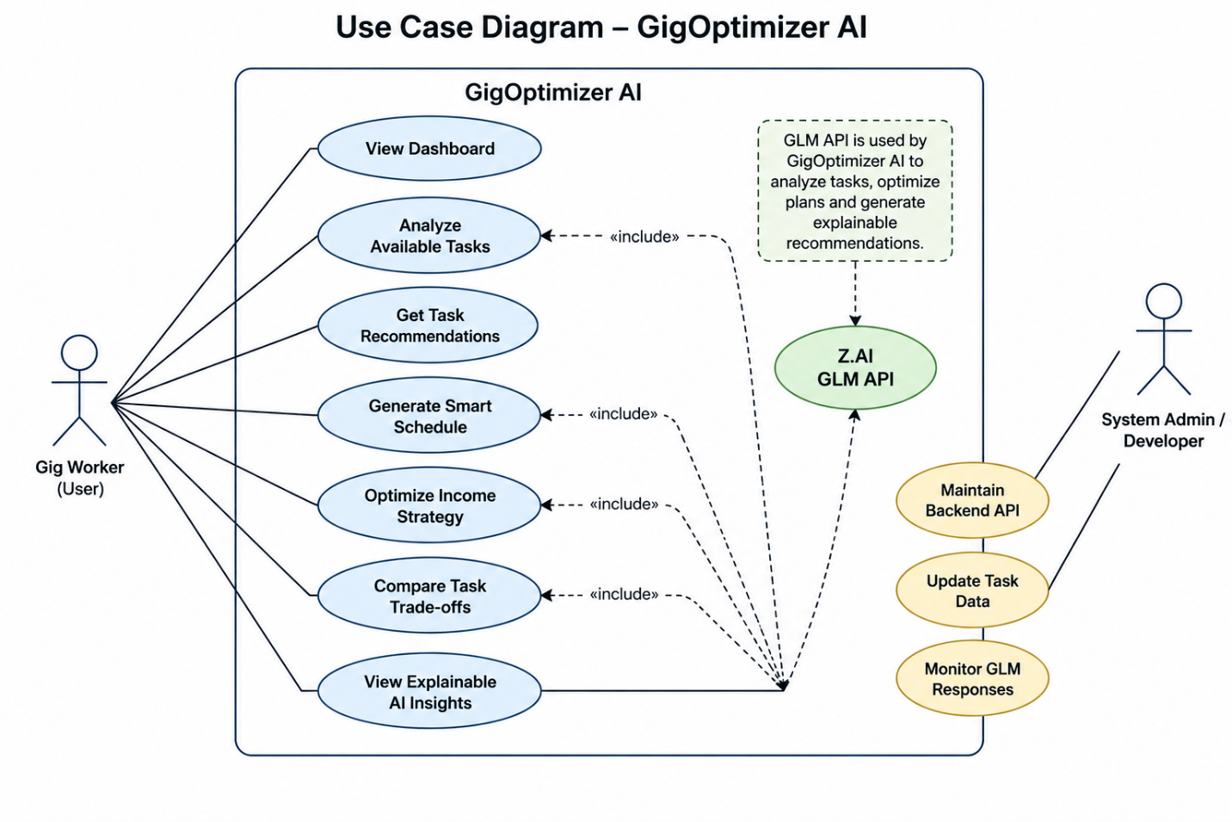

6. Features Included (Scope Definition)

AI-powered task recommendation dashboard

Smart schedule optimization • Income optimization advisor

Trade-off decision analysis

Explainable GLM-generated recommendations

Scenario-based decision simulation

7. Features Not Included (Scope Control)

Full production integration with real gig platforms

Live transactional marketplace functionality

Payment processing integration

Multi-user collaborative mode

Production-grade large scale deployment

8. Assumptions & Constraints
- LLM Cost Constraint:
Estimated token cost per average user session: approximately 4,000–8,000 tokens (4 GLM calls of ~1,500–2,000 tokens each). At ilmu-glm-5.1 pricing, this is estimated at USD 0.004–0.008 per session.
Cost management decisions:
  - Prompt caching: Worker profile blocks are pre-computed and cached server-side. Only variable task data is re-injected per call.
  - Task pre-filtering: Backend reduces task list to top 10 by raw efficiency before GLM injection, capping context at ~2,000 tokens regardless of platform task volume.
  - Temperature tuning: Lower temperature (0.4–0.5) for schedule and trade-off calls reduces token-expensive exploratory generation.
- Technical Constraints:
  - The system requires a stable internet connection for live GLM calls; demo mode activates automatically on API failure.
  - Current task data is simulated (8 tasks, 3 worker profiles); production integration with live gig platforms requires platform API partnerships not in scope for this hackathon.
  - GLM response parsing assumes JSON-formatted output; the backend strips Markdown fences but does not handle fundamentally malformed responses beyond fallback activation.
- Performance Constraints:
  - Target GLM response time: under 3 seconds per inference call under normal load.
  - The 30-second backend timeout per GLM call prevents hanging requests from blocking the Flask server.
- User Input:
  - The system is advisory — all decisions remain with the worker. GLM recommendations are presented as guidance, not commands.
  - Worker profiles are currently static (pre-seeded); real-world deployment would require dynamic profile updates from platform activity history.

9. Risks & Questions Throughout Development
- GLM Hallucination in Financial Figures
Risk: GLM may generate plausible but incorrect MYR earnings projections.
Mitigation: All monetary computations (fuel cost, gross pay, net pay, hourly rate) are pre-calculated in Python using deterministic business logic before injection into the GLM context. GLM's role is to reason about and explain pre-computed values, not to generate financial figures independently.

- Recommendation Consistency Across Calls
Risk: Two identical inputs may produce different ranked recommendations due to GLM temperature variance.
Mitigation: Temperature is set to 0.4–0.5 for decision-critical endpoints (schedule and trade-off). Task ranking uses temperature 0.7 to allow nuanced reasoning variation, which is acceptable as workers benefit from diverse perspectives.

- Worker Trust in AI Recommendations
Risk: Gig workers may distrust or ignore AI recommendations if they cannot understand the reasoning.
Mitigation: Every GLM recommendation includes a plain-language reason field. The trade-off analyzer provides conditions under which the losing option may be preferred, demonstrating nuance. The dashboard labels all GLM outputs clearly with the model identifier.

- API Rate Limiting
Risk: Under concurrent usage, GLM API rate limits may cause delayed or failed responses.
Mitigation: Demo fallback activates automatically on any API error, ensuring the system remains functional and demonstrable under all conditions during the hackathon.

